To APPLE APP STORE Approval Committee,

Thank you for you quick feedback! As requested, I’ve attached more detailed game instructions with screenshots as well as a video link to the APP in use. The app is a QR code treasure hunt completed across a church campus. Thus the game is played across both real life and virtual reality.

Please note:

* TAKE OVER APP uses no private API's.
* TAKE OVER APP uses no In App Purchase for in-app (financial) transactions.
* Users camera is only accessed by the user to scan QR Codes.
* Graphics and artwork featured in TAKE OVER APP were developed originally by a collaborating member on my team.
* App demo: <https://www.youtube.com/watch?v=e8MEfFdFrrs&t=4s>

Screenshot 1: Login Page.

The Login Page screen player doesn’t need to sign up. We will provide them a account and password in advance. It will have 24 teams in the camp and separate to 5 countries, Modern, Labor, Academic, Power,Wealth. Each country has different super power to earn resources. Basically We will not collect any user information, soNo security issue.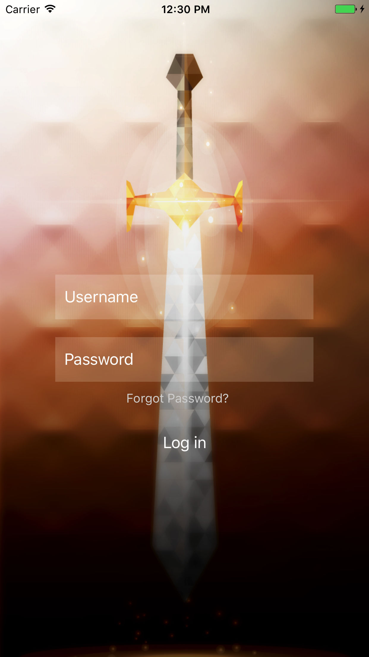

Screenshot 2: APP HOME SCREEN.

The home screen depicts the players’ team name and mascot and lists the resources earned. Click on resources to calculate their conversion rate for trade.

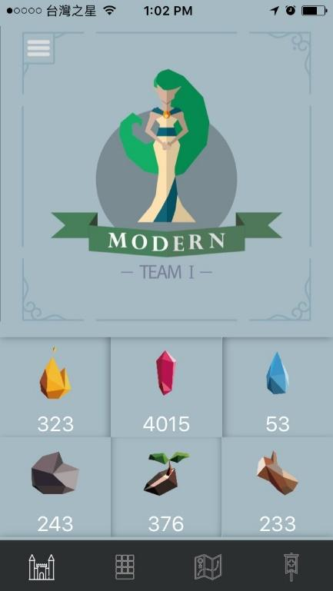

Screenshot 3: P.P. Island

This map displays the land purchased by each team. The team that purchases the most territory wins. The water mark floating on the map shows which team owns that plot of land.

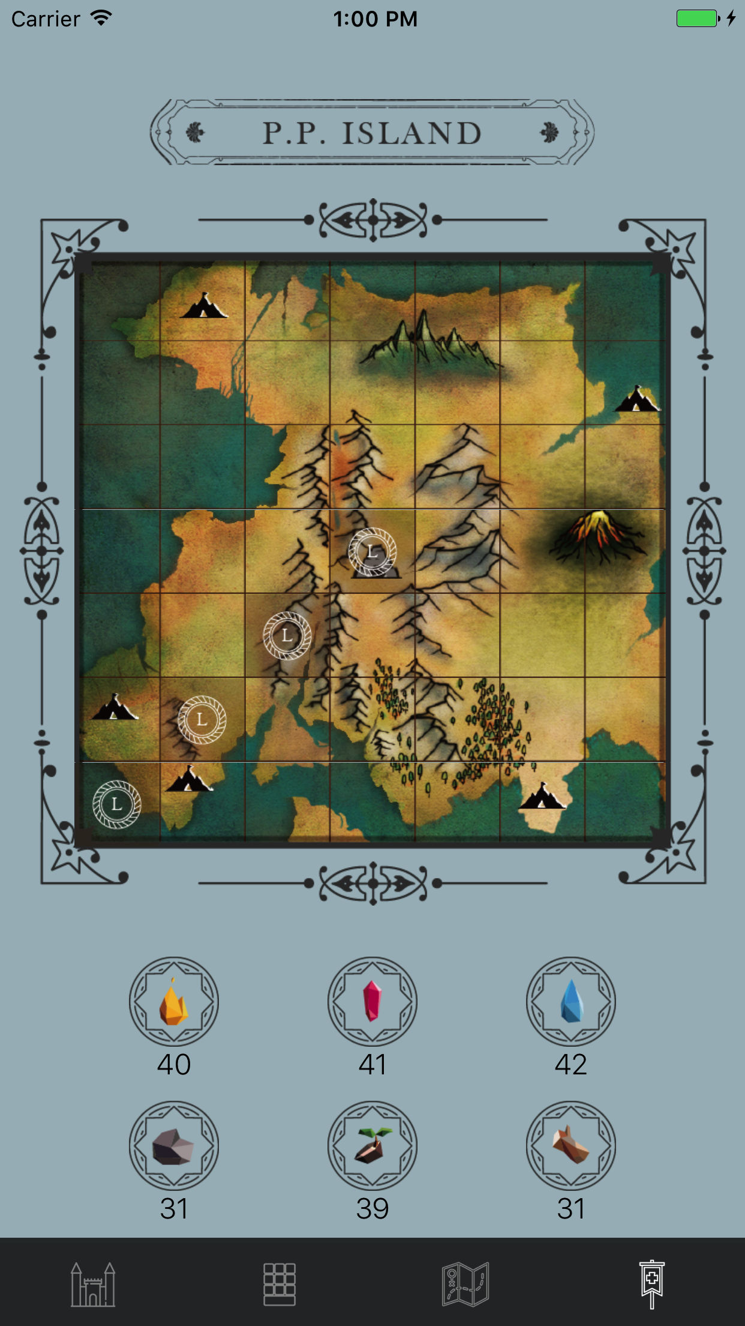

Screenshot 4: Treasure Map

This map is a representation of the real life campus in which this app will be used. The map marks where players should go to compete in real life puzzle games. When players complete a real life game, they scan a QR code to gain virtual resources or hints to help them in the virtual component of the game.

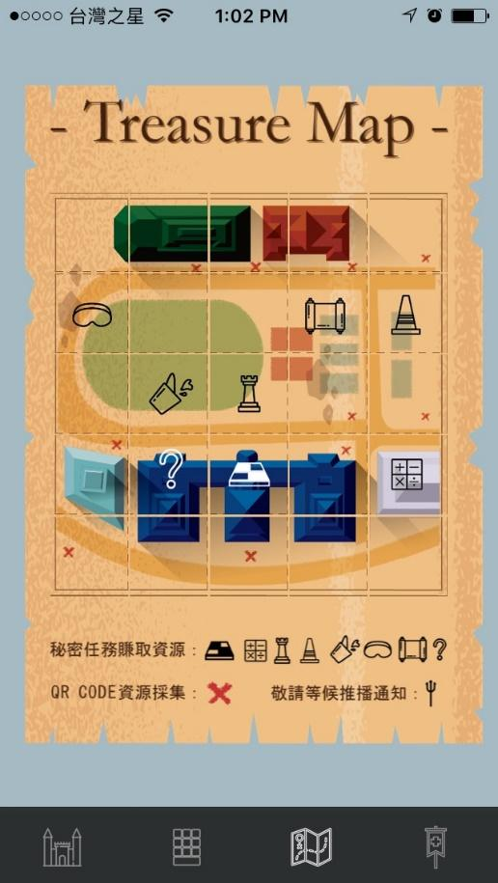

Screenshot 5: Last Ticket

This screen allows players to track which puzzles have been completed and which are yet to be done. Any hints players earn will also be displayed when the player clicks on the square. So the player will go to a specific spot to find the Puzzle Keeper (game host) and then play a game with him. If the player wins the game, Keeper will give them some virtual resources and a hint for the next game. If the player loses the game, they can buy the hint using virtual resources. As you can see on the screen, each puzzle has 3 statuses. The player’s goal is to collect all hints and figure out the question we give them to tell us a answer then they can earn resources.

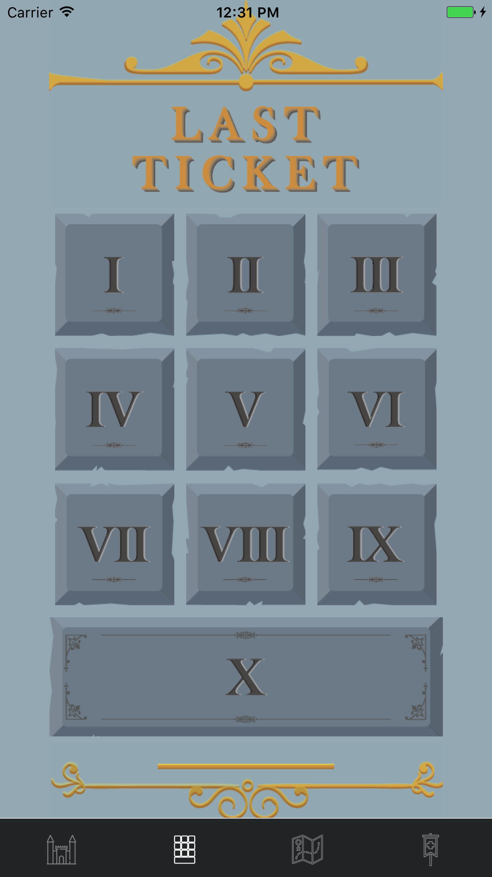

Screenshot 6: Drawer Screen

This Drawer screen we put some information about this camp like schedule, workshop detail, common questions, game rules. And we also put our church information and a feedback questionnaire on it. Most important is logout button is in here.

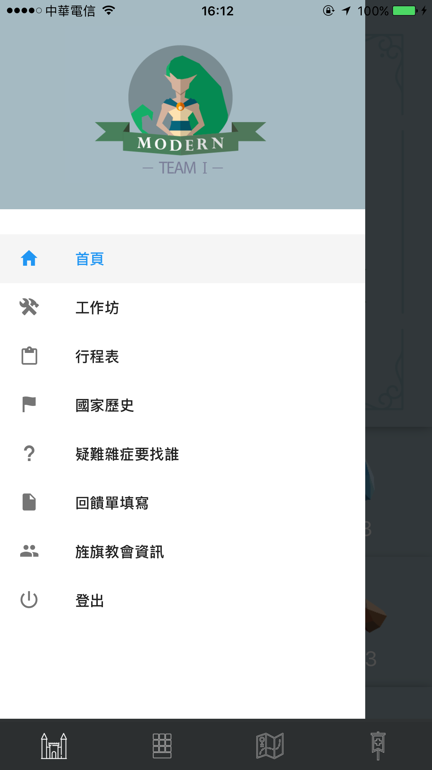

QRcode sample for test:



